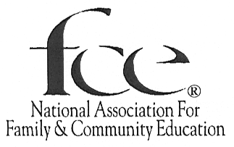

Community Service Award
(To be submitted to National FCE by State Affiliates. Local groups should apply to their states)
Due Date: March 1, 20____, or before, to the Oregon FCE President
PURPOSE: Recognize local FCE groups or individual FCE members who through their community service projects are changing the lives of others for the better.
Because of who we are and what we do, we are active in changing the lives around us for the better. Many of the projects that members work on deserve recognition but do not fall under the umbrella of any of the National FCE program awards. This award will encompass and honor those projects.
This is not a project award that carries a monetary reward. The reward comes in helping others.
RECOGNITION of the project will be given to one entry from each state. Each state will receive a CERTIFICATE and a set of HEARTH FIRE LESSONS. (The State organizations can recognize any entries however they choose.)
Each submission must include a program report book and a brochure. Entry books will be submitted on 8½X11 paper, stapled together, and will follow the format listed below. Award brochures should include pictures, facts and information about the project that helps you tell your story, and encourages others to seek more information about the organization.
A copy of the program report book and a brochure need to be mailed, by the State Affiliate, to National FCE Headquarters, 73 Cavalier Blvd Ste 106, Florence KY 41042, postmarked by April 15, of the current year.

COMMUNITY SERVICE
AWARD BOOK CRITERIA
Cover Page
Name of project_____________________________ State _____________________________
Person submitting the project __________________ Address __________________________
Pages as needed to answer the following:
Why did you select this project?
What were your goals and objectives?
What did members do to carry out the project?
Dollar amount spent on the project and how did you raise the money for the project?
How many FCE members were involved in carrying out the project?
How many non-FCE members did you reach?
Number of volunteer hours extended?
Were there other organizations involved? If so how?
What was the impact and scope of the project?
Was the project a success?
Did you reach your goal and objectives? Explain.
Would you change the plan of action? If so how?
Write a short summary of your work (100 words or less)

