|  |
| --- |
| **MPY TRI-LINE NEWS** |

**Volume 22, Issue 3 Marion, Polk, Yamhill Summer/Fall 2015**

** Hello,** Is it really fall? **I** guess that happens on the 23rd. The temperature makes me feel and think we are still in summer. Kids are back in school, so we all must be aware of school zones, buses and kids crossing streets. For some parents and grandparents the fall sports have started.

**October 5-7** will be here soon too. **I** hope you have gotten your registrations in for the **FCE State Conference in Wilsonville. "Let's Have A ball!"** Registrations can be found on our web site www.Oregon-FCE.org early registration fee is due by **Sept. 21** and hotel registration was due by **Sept. 13** to be assured of the special rate but go ahead and ask for the special rate if you have not made arrangements yet.

Classes for this year: **"Precious Water"** presented by **Kerry Mauk and Sandie Bolyard.** Water is a precious resource and a necessity of life. We will discuss how to use water wisely, recycle water and other experiences and wisdom to survive the drought.

**"Computer Terminology"** presented by **Gay Jarvinen.** Get a better understanding of computer lingo.

**The Story Lives On"** presented by **Janet Allen and Rosalee Ratto.** Explore **Oregon** folklore, legends and myths.

**"Hope on the Horizon"** presented by **Scott Teeples.** Learn what we can do to retain and build the **FCE** organization.

**"Talking with your Doctor"** presented by **Bonnie Teeples and Patti Malanaphy.** Talking to your doctor isn't always easy, this lesson will prepare you for your visit.

**"Mom's Toolbox"** presented by **Michael Denbo.** What are the basic tools for the lady of the house, first time homeowner or new college student.

**Wednesday's workshop: "Bubble & Squeak, Bangers and Toad-In-A-Hole, oh my!"** Presented

by **Sally Wyffels and Anne Engen.** Take a trip through **England's** history, famous people, places and food.

**Monday** there is a tour of **North Willamette Experimental Center.** Learn about the various crops they are working on and how the site works. In the afternoon a Glass Jar craft class will be offered

**Tuesday Evening Banquet: "Ball" night.** You are encouraged to bring a "ball gown" to wear. This is your chance to be creative. It can be funny or stylish, old-fashioned or far-out, long or short (but not too short), gloves or not! Show your stuff and **"Let's Have a Ball"!**

**Districts III and IV** have met several times planning for the **2016 State Conference.** *Yes it does take time to get the hotel and everything set up for a conference, it is not done overnight.*In **District III** our **September** lesson has been **"Save the Bees".** Our **October** lesson will be **"How to Feed a Family on a Budget"** and **November** will be **"Oregon Cranberries".** If you would like more information on these lessons and where they will be taught give me call and **I'll** be glad to get you set up. And leaders: Remember we will not leave materials at the training sites. If you want them mailed to you, you pay postage.

Also if you have changed your address, know of someone who would like to receive this newsletter or someone who received this newsletter and now is deceased please let us know so we can make the needed changes. Send the changes to **Susan Whitaker, 9875 Parker Rd., Monmouth, OR 97361-9762.**



**Lynda Nyseth,** Editor

503-835-2044 or LYNDATrose@aol.com

**Books for Baby Project**

**Connie Leavitt,** Chairman, Books for baby project in **Marion County** is still collecting items for the bags given out at the **Salem** hospital. She includes: A book and a bib along with a copy of the **MPY** newsletter and **FCE** brochure. These are given to the new mothers to encourage them to read to the babies and small children. The nurses at the hospital say they like giving them out and the mothers like them too.

**Vi and Jerry Shepherd** are still making the labels to put in the books. These say they are donated by **FCE** and our mission of strengthening families.

A big thank you to all who have contributed.

**C:\Users\Jim and Lynda\AppData\Local\Microsoft\Windows\Temporary Internet Files\Content.IE5\M13TEDXA\MC900357981[1].wmf**

**From the Desk of the District III Director**

The summer evenings are finally getting cooler. After so many days of 90 plus temperatures **I** am so ready for **Fall.** The many fires in our beautiful state will hopefully be getting surrounded and under control. The many, many firefighters working on the lines for hours and days, how can we begin to thank them for their sacrifice. And to their many families we offer so many blessings too.

As **Fall** begins we can plan to attend the **Fall Conference in Wilsonville.** After the **State Conference, Marion, Polk and Yamhill County Councils** will be planning for lessons for the **2016** year. So another year begins for our local **FCE** study groups. Memberships are due soon for the coming year as well. If you are inviting a friend to join your study group don't forget the **Keeper's Corner Scholarship** for new members.

**"Let's Have A Ball"** is the theme of the fall conference, **October 5-7.** From the classes presented we will decide the lessons we will be offering in **2016** in **District III.**

If you don't have your registration completed, it was in the **August** issue of **Oregon FCE News.** You can also go online to the state website, [www.Oregon-FCE.org.](http://www.oregon-fce.org./) **Anne Engen** and myself will be presenting a lesson on **England, "Bubble & Squeak, Bangers and Toad-in-A-Hole, oh My!",** at the **Wednesday** general meeting.

**District III and District IV** met at **Millersburg Park** in **August** to continue our planning for **2016 State Conference, "Be a Fan of FCE",** to be held in **Salem** at the **Red Lion Inn.** You will be getting more information concerning our district's roles in the conference as the year progresses. Each study group will be responsible and play a valuable role at the conference. The county councils need your help and ideas to make the **2016** conference a success.

Have a wonderful and fruitful **Fall.**

**Sally Wyffels,** District III Director

**Debra Driscoll,** Extension agent for **Yamhill/Polk County** retired earlier this year. She helped **FCE** so much with our lessons, arranging rooms for different meetings, answering a lot of questions and just being a great friend.

At our **Yamhill/Polk Spring Festival,** we had a large card for those attending to sign and wish her and her husband happy retirement. We gave her a suitcase as we heard they were wanting to do some traveling. And we gave her a soft grandma blanket as they are new grandparents. Here is a response she sent **Sally.**

 Dear **FCE** friends,

Thank you for the great suitcase and cozy blanket!  It was such a nice surprise to return from our trip to **Utah** and find them...plus the gigantic card...at the office.  **I** am slowly getting used to the retirement changes and having fun. Husband, **Dave,** is doing well. If any of you would like to stay in touch, my home email is [minar53@msn.com](mailto:minar53@msn.com) and our facebook page is "Debra Dave Driscoll."  It's been such a pleasure to work with you all, and have fun with you, too.

**Debra**

**Holidaze 2015**

**Monday, October 26**



**"Adventures with Quilters and Nomads in Mongolia"**

**Nancy and John Watts,** travelled twice to **Mongolia** to teach quilting skills at the **Quilting Center in Ulaanbaatar.**  They will share photos and stories of their adventures, including an insight into the nomadic life. The **Watt** will be displaying some of the local items they brought back with them and will have some beautiful silk pieces made by the **Mongolian** women for purchase.

On display will also be some quilts from **Washington County FCE members.**

**Tualatin United Methodist Church (ADA)**

**20200 SW Martinazzi Ave., Tualatin, OR 97062.** Please bring non-perishable food items or a contribution for the local food pantry. Deadline for registration is **October 16, FCE** members $18.50 and non-members $19.50. Doors open at 9:30 a.m. Lunch will be served.

From north or south:

* Travel on I-5,
* Take exit 289,
* Turn west onto SW Nyberg,
* Stay in the right to continue on SW Nyberg,
* Turn left only SW Martinazzi.

For more information contact: **Myrna Loucks, 503-693-1984 or Patty Bonney 503-246-3180**

Make check payable to **FCE WA County Advisory Council.** Mail to **Myrna Loucks, 7150 N. E. Stonewater St., Hillsboro, OR 97124-8340**

Quotable Quotes

"The difference between 'involvement' and 'commitment' is like an eggs-and-ham breakfast: the chicken was 'involved' - the pig was 'committed'."

***Volunteer Newsletter Staff***

**MPY Tri-Line News** is published quarterly and is supported by voluntary donations. Anyone may receive the newsletter. Send news articles, donations or inquiries to: **MPY Tri-Line News, 21461 S. Hwy 99W, Amity, OR 97101-2239**

Executive Editor: **Lynda Nyseth,** 21461 S. Hwy 99W, Amity, OR 97101-2239 Ph. (503) 835-2044

E-Mail [LYNDATrose@aol.com](mailto:LYNDATrose@aol.com)

***Column Editors***

Food: **Dorene Garland** (503) 769-4290

1030 W. Locust St., Stayton, OR 97383-1137

E-Mail [mgarland@wvi.com](mailto:mgarland@wvi.com)

Kid’s Corner:

Craft Projects: **Sharyl Michael** (503) 949-2057

Managing Editor: **Connie Leavitt** (503) 581-7393

E-Mail [cleavitt@wvi.com](mailto:cleavitt@wvi.com)

Proofreader: **Jim Nyseth**

Bookkeeper: **Linda Bird** (503) 843-2979

Mailing Committee: **Linda Bird, Dorene & Ralph Garland, Connie Leavitt, Sharyl Michael, Agnes Rover, Alene Showers, SallyWyffels**

Word Processing & Layout: **Lynda Nyseth**

***Contributors/County Council Chairs***

Yamhill/Polk Council: **Lynda Nyseth**

Marion Council: **Dorene Garland**

District III Director: **Sally Wyffels,** (503) 472-3091

E-Mail [sjwyffels67@yahoo.com](mailto:sjwyffels67@yahoo.com)

Advisors:

Send your mailing address and/or changes to:

**Susan Whitaker**

**9875 Parker Rd.**

**Monmouth, OR 97361-9762**

503-910-3569 or

E-Mail [susanwhitaker14@gmail.com](mailto:gswhitaker@meritel.net)

JUST A THOUGHT

If I was any slower, I’d be in reverse.

DONATIONS

Sharyl Michael

Lucille Ruch

Sally Wyffels

**

**District III & IV** have been making plans for the **2016 FCE Conference** that will be held in **Salem.**

Each county has been asked to raise a set amount of money to help with expenses. One group is having a "Brown Bag Raffle" as a fund raiser. One group has a "No Bake, Bake Sale", you pay what you think you would spend if you baked something. One group makes **Christmas** Wreaths each year to help fund projects during the year. These ideas are good to help pay membership dues too if your members are having a hard time paying dues. Other suggestions that have worked in groups is to pay a small amount each month or have the club pay national dues and members pay state dues. Some groups have the club pay the state dues and members pay the national dues. **I** hope that these suggestions will help you keep members and stay part of our great organization of **FCE.**

**Study Group Happenings**

**Ambitious Annies, from Dallas,** collect underwear and socks for local schools for the homeless students. This is a year round collection to be given at **Christmas** time. They also sell used books at each meeting, the money goes into their general fund.

This year the group took a field trip to **Albany** to visit the **Hobby Lobby Store**  and then had lunch at **Red Robin.**

**Creative Homemakers, from McMinnville,** donate to the layette project each month. They give knit or crochet booties and baby blankets, they are given to several area facilities. They also collect donations for the **Community Compassion Fund,** supported by **McMinnville Cooperative Ministries.**

**Amity FCE** tooka field trip to **Bob's Red Mill** it was enjoyed by three members. More planned on attending but things came up. **Yamhill/Polk County Council** also enjoyed at trip to **Bob's Red Mill.** We learned while there that many other **FCE** groups had taken the tour just recently, perhaps because of our "Whole Grains" lesson which was sponsored by **Bob's Red Mill. 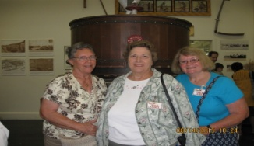Lynda N., Linda B. Sally W. (Yamhill/Polk County Council)**

**Sheridan FCE** joined the former **Mill Creek Study Group** for the "Whole Grains" lesson.

**Tomato drying and Dehydrating foods**

Presented by OSU Extension Service Master Food Preserver

1317 NE Dustin Ct., McMinnville

September 23rd

Sign up space is limited. 503-434-7517

Cost: $12.00 at sign up

Time: 6:00 - 8:00 pm

You will be taking Dehydrated tomatoes home.

***Oregon state University Extension Service*** *offers educational programs , activities, and materials*

*without discrimination based on age, color, gender identity or expression, genetic information*

*Marital status, national origin, race, religion, sex, sexual orientation, or veteran status.* ***Oregon***

***State University Extension Service*** *is a equal opportunity employer.*

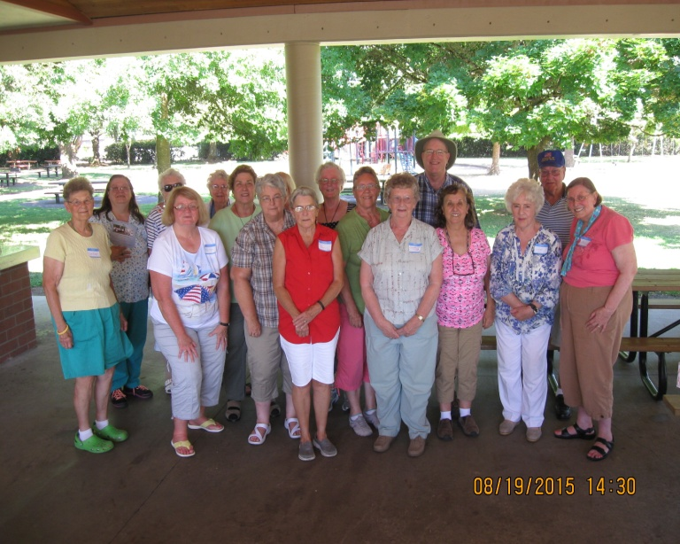

**District III and IV, Millersburg Park**

**Picnic and Planning Meeting 2016 Conference.**

 ***Martha Sarah Elizabeth Bruce***

*A book review by* ***Alene Showers***

A six year-old told her father, “**I** will not answer to that name ever again…**I** hate it and something has to be done about it.”

Several days later “Daddy” took his young daughter to the court house and began proceedings for a name change. When Daddy asked **Martha Sarah Elizabeth Bruce** what she would like for her new name, she replied that she didn’t know; she just wanted it changed. Since **Elizabeth** was already part of her name, and **Betty** is often a substitute for **Elizabeth,** the new name was decided upon. At age six **Betty Bruce Jones** was born, with a new birth certificate and all.

In **1938 Betty** married a young minister named **Charles Wilson** and **Betty** **Jones** became **Betty Wilson.**

**Betty and Charles’s** marriage lasted until **2004,** when **Charles** died from complications of **Alzheimer’s Disease. Betty** was now 89 years old and grieving. Her family recommended that she write her life story as a means of coping with her loss. ***Martha Sarah Elizabeth Bruce*** is **Betty’s** story, her autobiography of her early years in school and then her years of following her minister husband from one preaching assignment to another.

**Betty’s** book is a witty and touching account of her life. Throughout the pages her “voice” comes through. She writes as she speaks, with a subtle humor and frankness. Her vignettes give us a peak into what life was like, especially in her unique church-based community.

**I** met **Betty** when **I** moved into the **Hidden Lakes Retirement Center** last fall. We became friends. We share an appreciation of music, writing, and bridge. Most of all, we share a love of **Christ and His Church.**

**Betty** has been gracious enough to share her book with me, and has offered to lend me a copy to share with my **FCE** friends. Anyone wishing to read this book about this marvelous woman can contact me to borrow the book from **Betty**. And yes, if you want to learn why **Martha Sarah Elizabeth Bruce** changed her name, you must read the book.

*Taken from* ***News-Resigter/McMinnville, OR***

***April 15, 2014***

***by Elaine Rohse***

Driving highway 99W between **McMinnville and Amity** you will see the **"Whiteson"** sign. It appears to be a drowsy community but this once was a town with glory days.

Today, **Whiteson** has no school, no newspaper, no hotel, no bank. But history reminds us it once was a bustling railroad center and the crossing point for two railroads: the narrow gauge, **Portland to Airlie** line and the standard gauge, **Portland to Corvallis.**

**1915** it was an important shipping point for fruit, walnuts, poultry and vegetables. It had public school including high school, **Presbyterian Church, Artisan Lodge,** newspaper, two stores, hotel and travelers, often requiring overnight stops.

The founder, **Henry White,** in **1851,** headed across the **Plains to Oregon** with his wife and eight children. They first settled in **Marion** County, across the river from what was to become **Wheatland.** A few years later, they bought 300 acres at the **Wheatland** shipping port. Four years later, **White** sold the **Wheatland** acreage and bought 300 acres at the **Whiteson** site and gave the railroad a right-of-way and laid out "his" town, originally known as **Whites.** A post office was established **October 3, 1889.** The post office name was changed to **Whiteson** on **October 2, 1890.**

**Whiteson** residents built their one-room **District No. 78** school building. The building was started in fall **1892** and finished in **March 1893. April 1903** the district doubled its schoolroom space by adding a second room and ninth and tenth grades were added and a second teacher was hired.

**Whiteson's Front Street** had a store at either end, each with gas pumps out front. The post office was in the store at the southern end of **Front Street.**

**The Amish** were considering **Whiteson** as a possible location. **Oregon's** first **Amish** settlement was in the **Rock Creek** area of **Claskamas County** but, by **1895,**  some 20 years later, they had begun settling in the **Amity** area.

(continued on page 6)

(continued from page 5)

According to **Father Marinus Cawley,** in **"The Amish of Amity,"** the move to **Yamhill County** had been motivated in part by need of new farms for recently married couples. The desirable land in the area was surprisingly inexpensive. Some **Yamhill County Amish** families moved into houses within the village of **Whiteson,** which were already wired for electricity and **Whiteson** offered a grade school. Several **Amish** families took advantage of these ready-made **Whiteson** houses rather than building for themselves out on the farms. Those on **Cherry Street, Whiteson's** northernmost road, had direct access to acreage between their back door and the bluff overlooking the **Yamhill River.**

**Father Cawley, Monk of Guadalupe, Trappist Abbey,** described the public's perception of the **Amish:** "Beards, bonnets, buggies and buttons replaced by hook and eye".

**Whiteson's** glory days began to fade, **Americans** were looking to automobiles and trucks instead of trains. A crisis in the **Amish** settlement resulted in an exodus to **California.**

The ninth and tenth grades were dropped. **1935-36** was the last year school was held in **Whiteson.** In **1942, Whiteson,** consolidated with **Amity.**

**Whiteson--**the glory town founded by **Henry White--**today has no newspaper, no bank, no hotel--but it has historic **Whiteson Cemetery--**known also as **Taylor Cemetery.**

**Father Martinus** writes, **"The Amish** graves mostly are located in the southeast corner under the big madrone. The more elegant stones are of recent date, but the humble cement stones are original. In fact, the mold in which they were made still exists."

***I*** *thank* ***Elaine*** *for writing these articles she has on local towns.* ***I*** *remember at least one of the stores in* ***Whiteson*** *and sharing the road with the horse and buggy's. If you see the* ***Eagle's Nest*** *redwood carver, that is just a few yards from the store I remember.*

***I*** *hope that you enjoy these looking back articles. Perhaps you have some history of towns that you would like to share with our readers. Please send me the information. Lynda, editor*

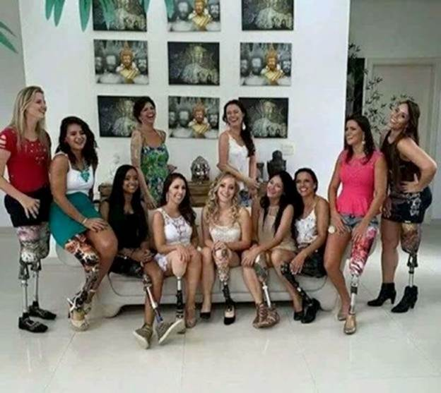

  We see lots of pictures of wounded male veterans, but women vets get wounded and maimed too. You may need to take a second, closer look though...The first thing I saw was a bunch of beautiful smiles.

**Thank you veterans both male and female!**

**Audrey Hepburn** wrote this poem to share her "beauty tips".

For attractive lips, speak words of kindness.

For lovely eyes, seek out the good in people.

For a slim figure, share your food with the hungry.

For beautiful hair, let a child run his/her fingers through it once a day.

For poise, walk with the knowledge that you never walk alone.

People, even more than things, have to be restored, renewed, revived, reclaimed and redeemed; never throw out anyone.

Remember, if you ever need a helping hand, you will discover that you have two hands; one for helping yourself and the other for helping others.

**The Black Dot:**

**A Beautiful and Inspiring Story!**

*Simple yet important message.*

One day, a professor entered the classroom and asked his students to prepare for a surprise test. They all waited anxiously at their desks for the exam to begin.

The professor handed out the exams with the text facing down, as usual. Once he handed them all out, he asked the students to turn over the papers.

To everyone's surprise, there were no questions--just a black dot in the center of the sheet of paper.

The professor, seeing the expression on everyone's faces, told them the following: "**I** want you to write about what you see there". The students, confused, got started on the inexplicable task.

At the end of the class, the professor took all the exams and started reading each one of them out loud, in front of all the students. All of them, with no exception, defined the black dot, trying to explain its position in the center of the sheet.

After all had been read, the classroom silent, the professor started to explain: **I'm** not going to grad you on this, **I** just wanted to give you something to think about. No one wrote about the white part of the paper. Everyone focused on the black dot--and the same happens in our lives. We have a white piece of paper to observe and enjoy, but we always focus on the dark spots. Our life is a gift given to us by **God,** with love and care and we always have reasons to celebrate--nature renewing itself every day, our friends around us, the job that provides our livelihood, the miracles we see every day...However, we insist on focusing only on the dark spot - the health issues that bother us, the lack of money, the complicated relationship with a family member, the disappointment with a friend.

The dark spots are very small when compared to everything we have in our lives, but they're the ones that pollute our mind.

Take your eyes away from the black dots in your life. Enjoy each one of your blessings, each moment that life gives you. Be happy and live a life filled with love!

Submitted by **Sally Wyffels,** District III Director

**Life Before Computers....**

An application was for employment

A program was a TV show

A cursor used profanity

A keyboard was a piano!

Memory was something that you lost with age

A CD was a bank account

And if you had a 3 1/2 inch floppy; you hoped nobody found out!

Compress was something you did to garbage not something you did to a file

And if you unzipped anything in public; you'd be in jail for awhile!

Log on was adding wood to a fire

Hard drive was a long trip on the road

A mouse pad was where a mouse lived

And a backup happened to your commode!

Cut - you did with a pocket knife

Paste you did with glue

A web was a spider's home

And a virus was the flu!

I guess I'll stick to my pad and paper

And the memory in my head

I hear nobody's been killed in a computer crash

But when it happens they wish they were dead!

~~~~~~~~~~~~~~~~~~~~~~~~~~~~~~~~~~~~~~

Someone out there either has too much spare time or is deadly at Scrabble.

DORMITORY: When you rearrange the letters: DIRTY ROOM

DESPERATION: When you rearrange the letters: A ROPE ENDS IT

SLOT MACHINES: When you rearrange the letters: CASH LOST IN ME

MOTHER-IN-LAW: When you rearrange the letters: WOMAN HITLER

ELEVEN PLUS TWO: When you rearrange the letters: TWELVE PLUS ONE

|  |
| --- |
|  |
|  |
|  |
|  |
|  |
|  |
|  |
|  |
|  |
|  |
|  |
|  |
|  |
|  |
|  |
|  |
|  |
|  |
| FCE CALENDAR  **SEPTEMBER**  **How to Feed a Family on a Budget** **OCTOBER (**CONT.)  23 Training Yamhill Co., 9:30-11:00 31 Halloween  Extension Office Meeting Rm **NOVEMBER**  24 Training Marion, 9:30 - 11:00 1 Daylight Savings time ends  4-Corners Fire Station 3 Election Day  28 Marion Co. Council, 9:30 6 Deadline for MPY articles  4-Corners Fire Station 11 Veterans Day  **OCTOBER** 13 Yamhill/Polk Co. Council, 9:30  5-7 Oregon State Conference Sandwich Express, McMinnville  Wilsonville, OR 20 Mail MPY, 9:15  12 Columbus Day 4-Corners Fire Station  23 District III Lesson Planning for 2016 23 Marion Co. Council, 9:30  Polk Co. Extension Office, 9:00-12:00 4-Corners Fire Station  26 Marion Co. Council, 9:30 26 Thanksgiving  4-Corners Fire Station **DECEMBER**  Holidaze 2015, Washington Co. 24 Christmas Eve  **Oregon Cranberries** 25 Christmas Day  28 Training Polk Co. 9:30-11:00  Polk Co. Extension Office  29 Training Marion Co. 9:30-11:00  4-Corners Fire Station  Washington Co. Holidaze 2014  9:30, Tualatin, OR  Oregon Association for Family & Community Education |